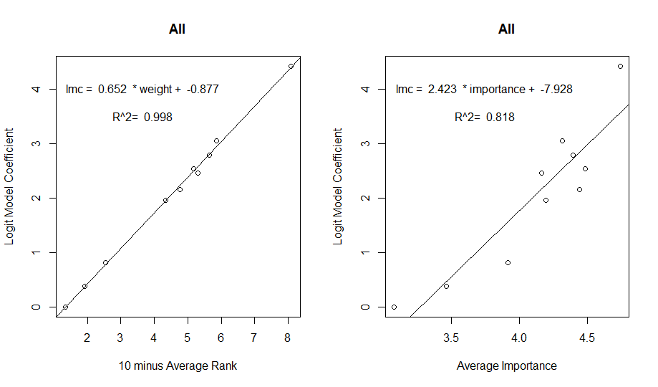

[1] "All"

> summary(logitModel)

Call:

mlogit(formula = Choice ~ FoodProvision + NaturalProducts + CarbonStorage +

CoastalProtection + CoastalLivelihoods + TourismRecreation +

IconicPlacesSPecies + CleanWaters + Biodiversity | 0, data = longData,

alt.levels = paste(1:nAltsPerSet), shape = "long", method = "nr",

print.level = 0)

Frequencies of alternatives:

1 2 3 4 5

0.22895 0.21745 0.15461 0.18805 0.21094

nr method

5 iterations, 0h:0m:6s

g'(-H)^-1g = 0.00417

successive function values within tolerance limits

Coefficients :

Estimate Std. Error t-value Pr(>|t|)

FoodProvision 3.048499 0.026886 113.386 < 2.2e-16 \*\*\*

NaturalProducts 0.386691 0.024224 15.963 < 2.2e-16 \*\*\*

CarbonStorage 1.961944 0.026770 73.290 < 2.2e-16 \*\*\*

CoastalProtection 2.787333 0.026918 103.549 < 2.2e-16 \*\*\*

CoastalLivelihoods 2.455320 0.026204 93.700 < 2.2e-16 \*\*\*

TourismRecreation 0.812899 0.025030 32.477 < 2.2e-16 \*\*\*

IconicPlacesSPecies 2.153488 0.026695 80.669 < 2.2e-16 \*\*\*

CleanWaters 4.424704 0.028052 157.735 < 2.2e-16 \*\*\*

Biodiversity 2.539208 0.026931 94.285 < 2.2e-16 \*\*\*

---

Signif. codes: 0 ‘\*\*\*’ 0.001 ‘\*\*’ 0.01 ‘\*’ 0.05 ‘.’ 0.1 ‘ ’ 1

Log-Likelihood: -53140

> cbind(aveRank, Rank = rank(aveRank))

Rank

FoodProvision 4.129790 2

AboriginalNeeds 8.661722 10

NaturalProducts 8.085290 9

CarbonStorage 5.653894 7

CoastalProtection 4.344870 3

CoastalLivelihoods 4.706634 4

TourismRecreation 7.458179 8

IconicPlacesSPecies 5.230738 6

CleanWaters 1.911001 1

Biodiversity 4.817882 5

> importance

FoodProvision AboriginalNeeds NaturalProducts CarbonStorage CoastalProtection

4.315681 3.082164 3.463232 4.197439 4.397425

CoastalLivelihoods TourismRecreation IconicPlacesSPecies CleanWaters Biodiversity

4.162945 3.915803 4.444444 4.740556 4.487572

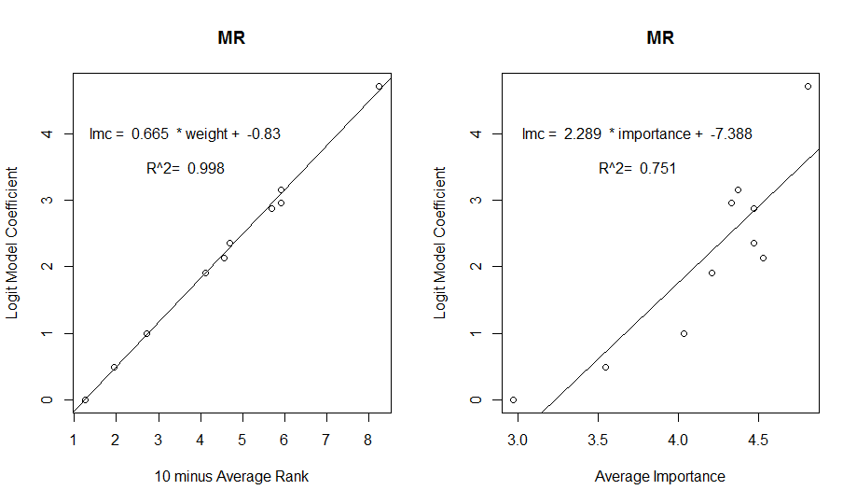

> Prov

[1] "MR"

> summary(logitModel)

Call:

mlogit(formula = Choice ~ FoodProvision + NaturalProducts + CarbonStorage +

CoastalProtection + CoastalLivelihoods + TourismRecreation +

IconicPlacesSPecies + CleanWaters + Biodiversity | 0, data = longData,

alt.levels = paste(1:nAltsPerSet), shape = "long", method = "nr",

print.level = 0)

Frequencies of alternatives:

1 2 3 4 5

0.22800 0.21381 0.16394 0.18289 0.21137

nr method

5 iterations, 0h:0m:1s

g'(-H)^-1g = 0.0021

successive function values within tolerance limits

Coefficients :

Estimate Std. Error t-value Pr(>|t|)

FoodProvision 3.158842 0.066859 47.2464 < 2.2e-16 \*\*\*

NaturalProducts 0.487781 0.059320 8.2228 2.22e-16 \*\*\*

CarbonStorage 1.901183 0.065331 29.1007 < 2.2e-16 \*\*\*

CoastalProtection 2.880424 0.066489 43.3216 < 2.2e-16 \*\*\*

CoastalLivelihoods 2.965092 0.065958 44.9541 < 2.2e-16 \*\*\*

TourismRecreation 0.990038 0.061883 15.9985 < 2.2e-16 \*\*\*

IconicPlacesSPecies 2.138971 0.066190 32.3156 < 2.2e-16 \*\*\*

CleanWaters 4.715839 0.070895 66.5183 < 2.2e-16 \*\*\*

Biodiversity 2.361478 0.065936 35.8145 < 2.2e-16 \*\*\*

---

Signif. codes: 0 ‘\*\*\*’ 0.001 ‘\*\*’ 0.01 ‘\*’ 0.05 ‘.’ 0.1 ‘ ’ 1

Log-Likelihood: -8686.4

> cbind(aveRank, Rank = rank(aveRank))

Rank

FoodProvision 4.088020 2

AboriginalNeeds 8.745721 10

NaturalProducts 8.066015 9

CarbonStorage 5.887531 7

CoastalProtection 4.317848 4

CoastalLivelihoods 4.097800 3

TourismRecreation 7.288509 8

IconicPlacesSPecies 5.442543 6

CleanWaters 1.760391 1

Biodiversity 5.305623 5

> importance

FoodProvision AboriginalNeeds NaturalProducts CarbonStorage CoastalProtection

4.371921 2.970516 3.543424 4.205882 4.469136

CoastalLivelihoods TourismRecreation IconicPlacesSPecies CleanWaters Biodiversity

4.325980 4.034483 4.528256 4.802956 4.465517

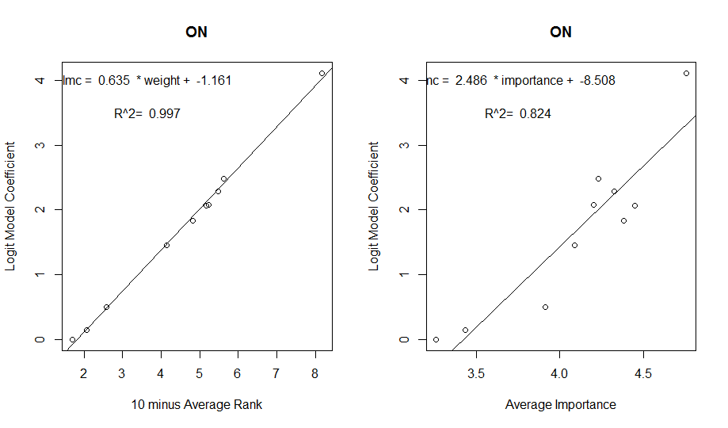> Prov

[1] "ON"

> summary(logitModel)

Call:

mlogit(formula = Choice ~ FoodProvision + NaturalProducts + CarbonStorage +

CoastalProtection + CoastalLivelihoods + TourismRecreation +

IconicPlacesSPecies + CleanWaters + Biodiversity | 0, data = longData,

alt.levels = paste(1:nAltsPerSet), shape = "long", method = "nr",

print.level = 0)

Frequencies of alternatives:

1 2 3 4 5

0.22200 0.21025 0.15500 0.19462 0.21813

nr method

5 iterations, 0h:0m:1s

g'(-H)^-1g = 0.000151

successive function values within tolerance limits

Coefficients :

Estimate Std. Error t-value Pr(>|t|)

FoodProvision 2.487454 0.063045 39.4553 < 2.2e-16 \*\*\*

NaturalProducts 0.150426 0.058230 2.5833 0.009785 \*\*

CarbonStorage 1.450860 0.062450 23.2325 < 2.2e-16 \*\*\*

CoastalProtection 2.292222 0.062936 36.4214 < 2.2e-16 \*\*\*

CoastalLivelihoods 2.080192 0.061324 33.9213 < 2.2e-16 \*\*\*

TourismRecreation 0.500808 0.059647 8.3962 < 2.2e-16 \*\*\*

IconicPlacesSPecies 1.829006 0.063103 28.9846 < 2.2e-16 \*\*\*

CleanWaters 4.111903 0.067160 61.2252 < 2.2e-16 \*\*\*

Biodiversity 2.066866 0.062606 33.0136 < 2.2e-16 \*\*\*

---

Signif. codes: 0 ‘\*\*\*’ 0.001 ‘\*\*’ 0.01 ‘\*’ 0.05 ‘.’ 0.1 ‘ ’ 1

Log-Likelihood: -9170.4

> cbind(aveRank, Rank = rank(aveRank))

Rank

FoodProvision 4.3750 2

AboriginalNeeds 8.3025 10

NaturalProducts 7.9300 9

CarbonStorage 5.8600 7

CoastalProtection 4.5150 3

CoastalLivelihoods 4.7650 4

TourismRecreation 7.4075 8

IconicPlacesSPecies 5.1850 6

CleanWaters 1.8325 1

Biodiversity 4.8275 5

> importance

FoodProvision AboriginalNeeds NaturalProducts CarbonStorage CoastalProtection

4.231738 3.260652 3.434343 4.087719 4.325815

CoastalLivelihoods TourismRecreation IconicPlacesSPecies CleanWaters Biodiversity

4.204030 3.912281 4.381910 4.755051 4.451128